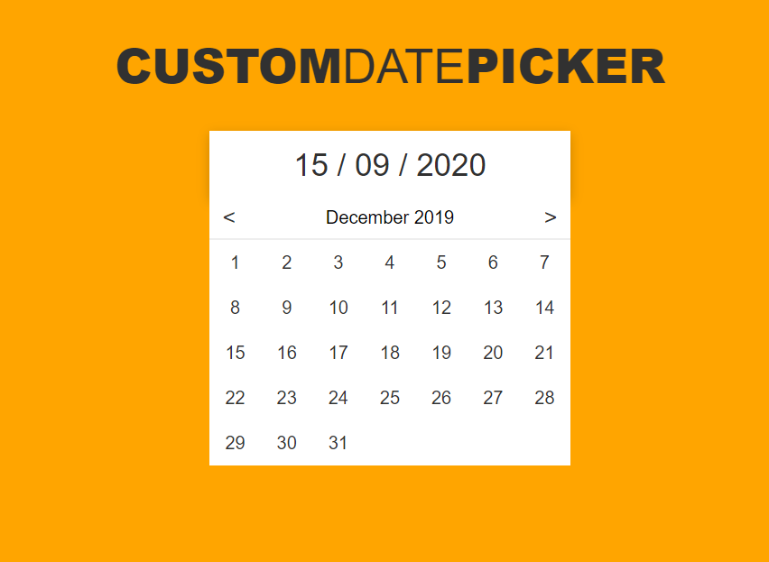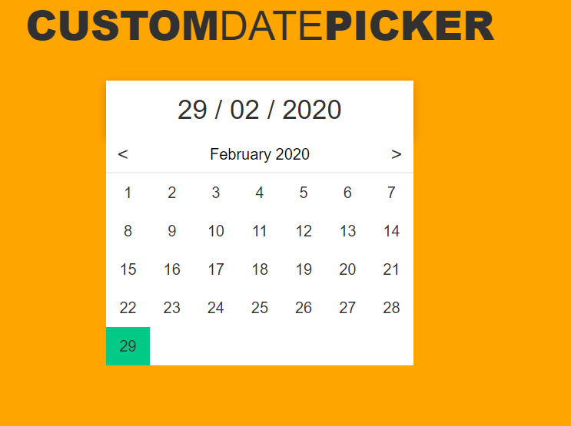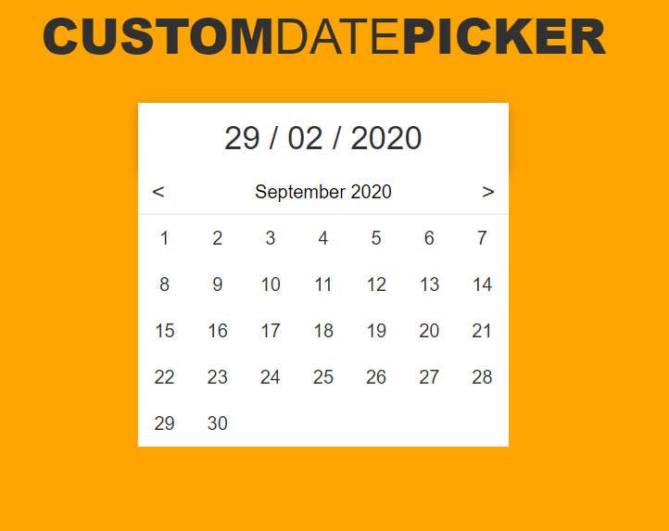

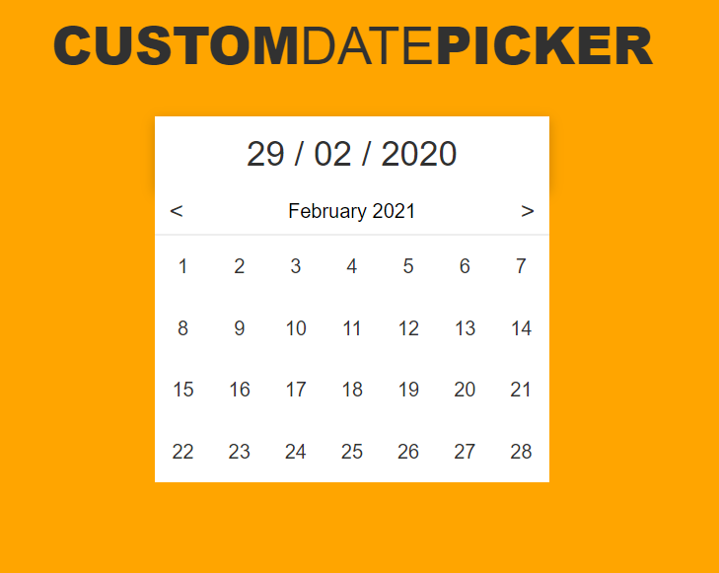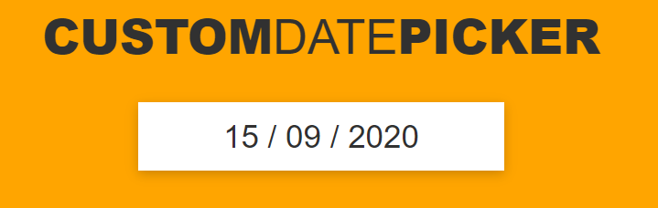

ARYAMAN MISHRA 19BCE1027

Index.html

<!DOCTYPE html>

<html lang="en">

<head>

<meta charset="UTF-8">

<meta name="viewport" content="width=device-width, initial-scale=1.0">

<meta http-equiv="X-UA-Compatible" content="ie=edge">

<title>Date Picker</title>

<script>

const date_picker_element = document.querySelector('.date-picker');

const selected_date_element = document.querySelector('.date-picker .selected-date');

const dates_element = document.querySelector('.date-picker .dates');

const mth_element = document.querySelector('.date-picker .dates .month .mth');

const next_mth_element = document.querySelector('.date-picker .dates .month .next-mth');

const prev_mth_element = document.querySelector('.date-picker .dates .month .prev-mth');

const days_element = document.querySelector('.date-picker .dates .days');

const months = ['January', 'February', 'March', 'April', 'May', 'June', 'July', 'August', 'September', 'October', 'November', 'December'];

let date = new Date();

let day = date.getDate();

let month = date.getMonth();

let year = date.getFullYear();

let selectedDate = date;

let selectedDay = day;

let selectedMonth = month;

let selectedYear = year;

mth_element.textContent = months[month] + ' ' + year;

selected_date_element.textContent = formatDate(date);

selected_date_element.dataset.value = selectedDate;

populateDates();

// EVENT LISTENERS

date_picker_element.addEventListener('click', toggleDatePicker);

next_mth_element.addEventListener('click', goToNextMonth);

prev_mth_element.addEventListener('click', goToPrevMonth);

// FUNCTIONS

function toggleDatePicker (e) {

if (!checkEventPathForClass(e.path, 'dates')) {

dates_element.classList.toggle('active');

}

}

function goToNextMonth (e) {

month++;

if (month > 11) {

month = 0;

year++;

}

mth_element.textContent = months[month] + ' ' + year;

populateDates();

}

function goToPrevMonth (e) {

month--;

if (month < 0) {

month = 11;

year--;

}

mth_element.textContent = months[month] + ' ' + year;

populateDates();

}

function populateDates (e) {

days_element.innerHTML = '';

let amount_days = 31;

if (month == 1) {

amount_days = 28;

}

if(month==0 ||month==3||month==5 ||month==8 ||month==10){

amount_days = 30;

}

if(year%4==0 && month==1)

{

amount_days=29;

}

for (let i = 0; i < amount_days; i++) {

const day_element = document.createElement('div');

day_element.classList.add('day');

day_element.textContent = i + 1;

if (selectedDay == (i + 1) && selectedYear == year && selectedMonth == month) {

day_element.classList.add('selected');

}

day_element.addEventListener('click', function () {

selectedDate = new Date(year + '-' + (month + 1) + '-' + (i + 1));

selectedDay = (i + 1);

selectedMonth = month;

selectedYear = year;

selected_date_element.textContent = formatDate(selectedDate);

selected_date_element.dataset.value = selectedDate;

populateDates();

});

days_element.appendChild(day_element);

}

}

// HELPER FUNCTIONS

function checkEventPathForClass (path, selector) {

for (let i = 0; i < path.length; i++) {

if (path[i].classList && path[i].classList.contains(selector)) {

return true;

}

}

return false;

}

function formatDate (d) {

let day = d.getDate();

if (day < 10) {

day = '0' + day;

}

let month = d.getMonth() + 1;

if (month < 10) {

month = '0' + month;

}

let year = d.getFullYear();

return day + ' / ' + month + ' / ' + year;

}

</script>

<link rel="stylesheet" href="main.css" />

</head>

<body>

<h1>CUSTOM<span>DATE</span>PICKER</h1>

<div class="date-picker">

<div class="selected-date"></div>

<div class="dates">

<div class="month">

<div class="arrows prev-mth">&lt;</div>

<div class="mth"></div>

<div class="arrows next-mth">&gt;</div>

</div>

<div class="days"></div>

</div>

</div>

<script src="main.js"></script>

</body>

</html>

Main.css

* {

margin: 0;

padding: 0;

box-sizing: border-box;

}

body {

background-color: orange;;

font-family: 'Saira', Arial, Helvetica, sans-serif;

}

h1 {

margin: 30px 0px;

color: #313131;

font-size: 42px;

font-weight: 900;

text-align: center;

}

h1 span {

font-weight: 300;

}

.date-picker {

position: relative;

width: 100%;

max-width: 320px;

height: 60px;

background-color: #FFF;

margin: 30px auto;

box-shadow: 0px 3px 10px rgba(0, 0, 0, 0.2);

cursor: pointer;

user-select: none;

}

.date-picker:hover {

background-color: #F3F3F3;

}

.date-picker .selected-date {

width: 100%;

height: 100%;

display: flex;

justify-content: center;

align-items: center;

color: #313131;

font-size: 28px;

}

.date-picker .dates {

display: none;

position: absolute;

top: 100%;

left: 0;

right: 0;

background-color: #FFF;

}

.date-picker .dates.active {

display: block;

}

.date-picker .dates .month {

display: flex;

justify-content: space-between;

align-items: center;

border-bottom: 2px solid #EEE;

}

.date-picker .dates .month .arrows {

width: 35px;

height: 35px;

display: flex;

justify-content: center;

align-items: center;

color: #313131;

font-size: 20px;

}

.date-picker .dates .month .arrows:hover {

background-color: #F3F3F3;

}

.date-picker .dates .month .arrows:active {

background-color: #00CA85;

}

.date-picker .dates .days {

display: grid;

grid-template-columns: repeat(7, 1fr);

height: 200px;

}

.date-picker .dates .days .day {

display: flex;

justify-content: center;

align-items: center;

color: #313131;

}

.date-picker .dates .days .day.selected {

background-color: #00CA85;

}